1. Create a schema based on the given dataset

create table agent_performance (slno int, date string,agentname string, totalchats int, averageresponsetime string, averageresolutiontime string, avergaerating float, totalfeedback int ) row format delimited fields terminated by ',' lines terminated by '\n' tblproperties ("skip.header.line.count"="1");

1. Dump the data inside the hdfs in the given schema location.

load data inpath 'file:///tmp/hive_classes/AgentPerformance.csv' into table agent_perfromance;

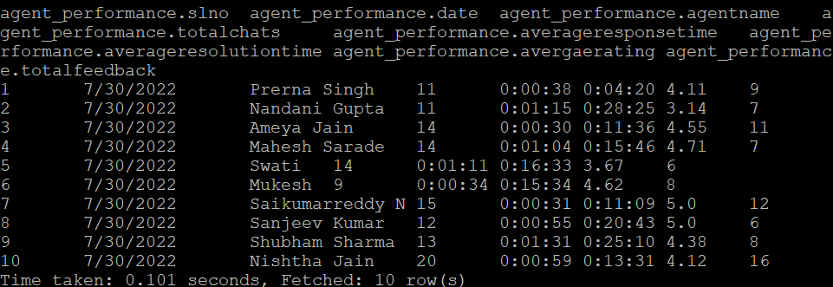

1. List of all agents' names.

select distinct agentname from agent_performance;

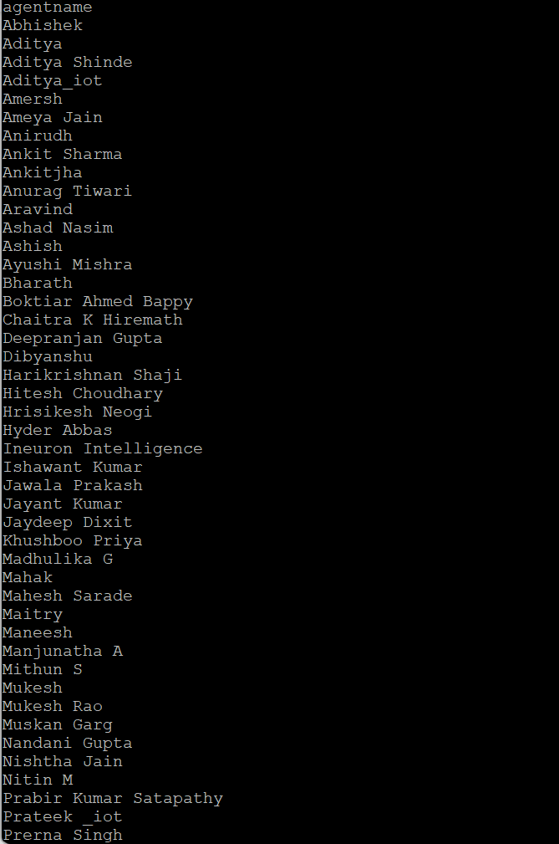

1. Find out agent average rating.

select agentname as Agent_Name,avg(avergaerating) as Avg_Rating from agent_performance group by agentname;

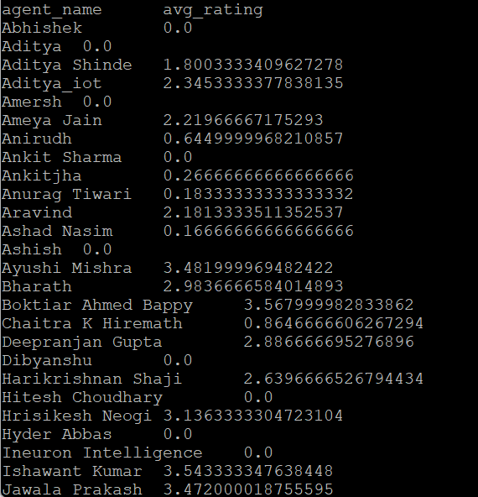

1. Total working days for each agents

select agentname as Agent_Name, count(distinct(date)) as Working_Days from agent_performance group by agentname;

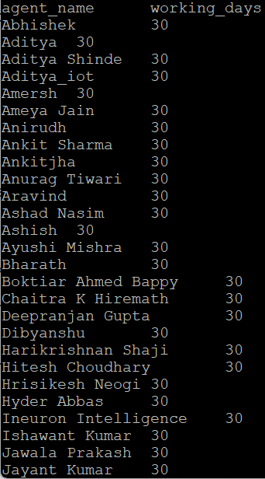

1. Total query that each agent have taken

select agentname as Agent_Name, sum(totalchats) as Total_Queries from agent_performance group by agentname;

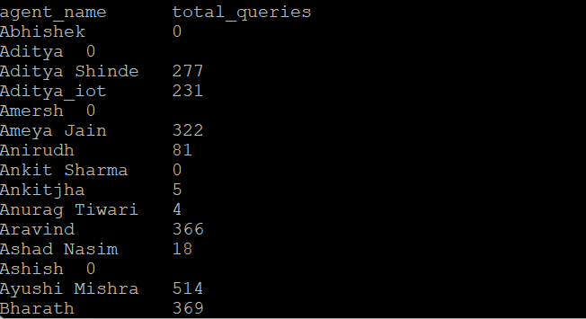

1. Total Feedback that each agent have received

select agentname as Agent_Name, sum(totalfeedback) as Total_Feedbacks from agent_performance group by agentname;

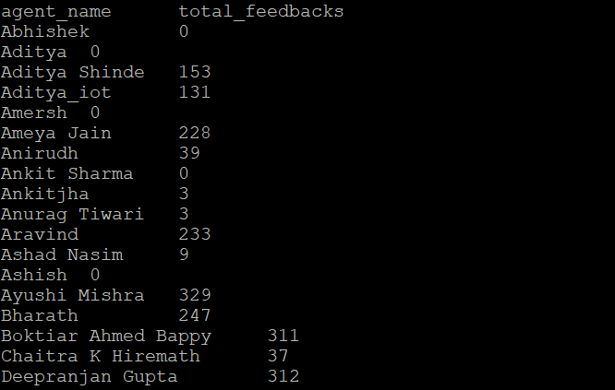

1. Agent name who have average rating between 3.5 to 4

select distinct agentname as Agent_Name from agent_performance where avergaerating between 3.5 and 4;

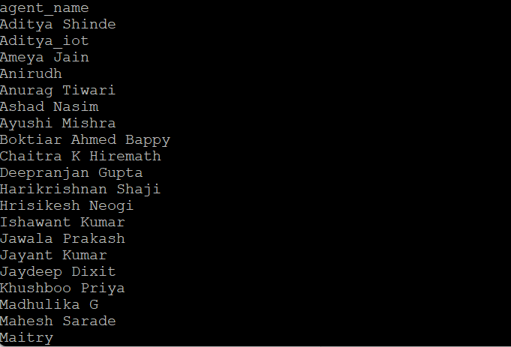

1. Agent name who have rating less than 3.5

select distinct agentname as Agent_Name from agent_performance where avergaerating < 3.5;

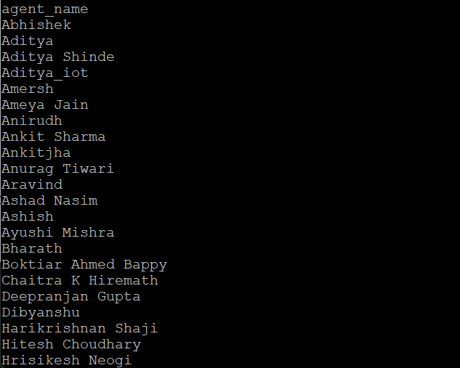

1. Agent name who have rating more than 4.5

select distinct agentname as Agent_Name from agent_performance where avergaerating > 4.5;

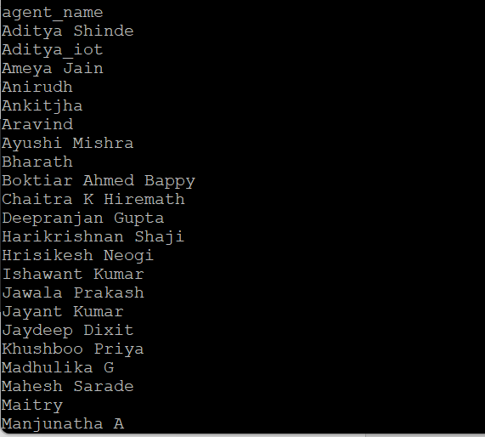

1. How many feedback agents have received more than 4.5 average

select agentname, sum(totalfeedback) as feedback from agent_performance where avergaerating > 4.5 group by agentname;

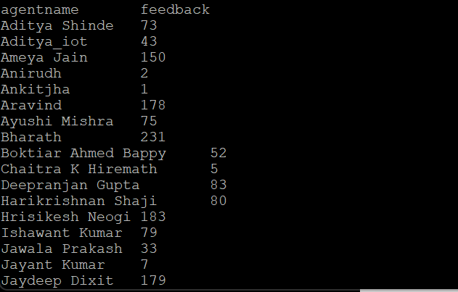

1. average weekly response time for each agent

select agentname, sum(cast(substr(averageresponsetime,3,2) as decimal(20,10)))+(sum(cast(substr(averageresponsetime,6,2) as decimal(20,10)))/60) rt,

date_format(date_trunc('month', a.event_date), '%m/%d/%Y') as date

from agent_performance group by agentname;

1. average weekly resolution time for each agents

select agentname, sum(cast(substr(averageresultiontime,3,2) as decimal(20,10)))+(sum(cast(substr(averageresulutiontime,6,2) as decimal(20,10)))/60) rt, date_format(date_trunc('month', a.event_date), '%m/%d/%Y') as date

from agent_performance group by agentname;

1. Find the number of chat on which they have received a feedback

select agentname,sum(totalchats) as numberofchats from agent_performance where totalchats > 0 group by agentname;

1. Total contribution hour for each and every agents weekly basis

select agentname, (sum(cast(substr(averageresultiontime,3,2) as decimal(20,10)))+(sum(cast(substr(averageresulutiontime,6,2) as decimal(20,10)))/60))/60 hour, date_format(date_trunc('month', a.event_date), '%m/%d/%Y') as date

from agent_performance group by agentname;

1. Perform inner join, left join and right join based on the agent column and after joining the table export that data into your local system.

Select a.*, b.* from agent_performance a inner join agent_login_report b on a.agentname = b.agentname;

Select a.*, b.* from agent_performance a left join agent_login_report b on a.agentname = b.agentname;

Select a.*, b.* from agent_performance a right join agent_login_report b on a.agentname = b.agentname;

1. Perform partitioning on top of the agent column and then on top of that perform bucketing for each partitioning.

create table agentperformance_part1(slno int, date string,totalchats int,averageresponsetime string,averageresulutiontime string,averagerating float,totalfeedback int) partitioned by (agentname string);

insert overwrite table agentperformance_part1 partition(agentname) select slno,date,totalchats,averageresponsetime,averageresolutiontime,avergaerating,totalfeedback from agent_performance;

create table agentperformance_buket(slno int, agentname string,date string,totalchats int,averageresponsetime string,averageresulutiontime string,averagerating float,totalfeedback int) clustered by (agentname) into 4 buckets row format delimited fields terminated by ‘,’;

from agent_performance insert overwrite table agentperformance_bucket select slno,date,totalchats,averageresponsetime,averageresolutiontime,avergaerating,totalfeedback from agent_performance;